**A model for circadian oscillations in the Drosophila period protein (PER) – Interim Report**

**Project Team:**

Matthew Browe, Eric Chen, Tejas Goculdas, Madan Gopal

**Problem statement:**

Circadian rhythms are set and extremely important metabolic processes that cyclically regulate biological outcomes on a 24-hour cycle. This response to 24-hour light cycles is evolutionarily conserved and observed in all domains of life. The circadian rhythm is a stable oscillatory response under steady state conditions. In this study, we seek to recreate the results published by Goldbeter, 1995 [1].

**Progress and Outcomes:**

1. **Validate and reproduce results presented by Goldbeter, 1995:**

Major results from the baseline Goldbetter model have been successfully duplicated in MATLAB and are depicted in Figures 1-3.

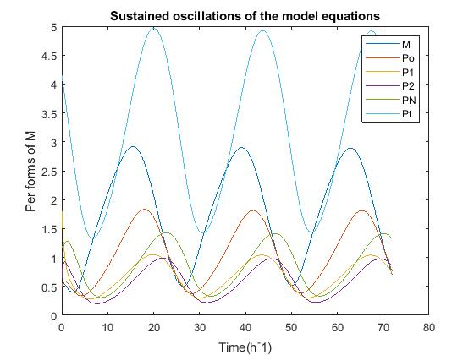

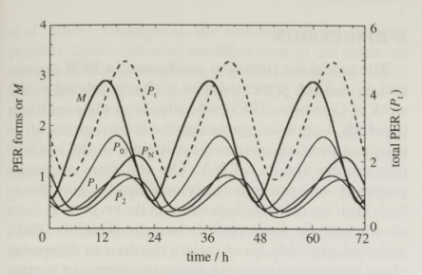Figure 1a and 1b: Oscillatory protein levels from per mRNA (Goldbetter, 1995) and reproduced results,

the latter including an additional plot of total protein concentration

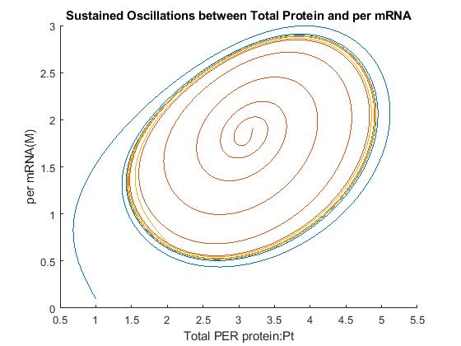

*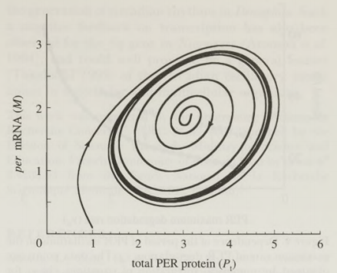Figure 2a and 2b: All initials conditions favor tendency towards a limit cycle*

as shown (Goldbetter, 1995) and reproduced results

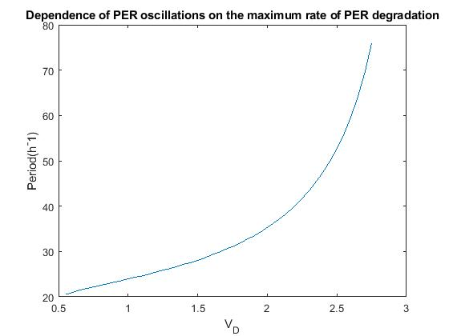

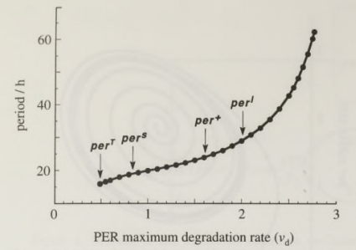

Figure 3a and 3b: Period for per induced oscillation vs. max per protein degradation rate (Goldbetter, 1995)

and reproduced results

1. **Stability Analysis Progress:**

We have derived the Jacobian matrix for the Goldbetter model, defined by the ordinary differential equations in Figure 4.

$$f_{1}= \frac{dM}{dt}= v_{s}\frac{K_{1}^{n}}{K_{1}^{n}+P_{N}^{n}}- v_{m}\frac{M}{K_{m}+M}$$

$$f_{2}=\frac{dP_{0}}{dt}= k_{s}M-V_{1}\frac{P_{0}}{K_{1}+P_{0}}+ V_{2}\frac{P_{1}}{K_{2}+P_{1}}$$

$$f_{3}=\frac{dP_{1}}{dt}= V_{1}\frac{P_{0}}{K_{1}+P_{0}}- V_{2}\frac{P_{1}}{K_{2}+P_{1}}- V_{3}\frac{P_{1}}{K_{3}+P_{1}}+ V_{4}\frac{P_{2}}{K_{4}+P_{2}}$$

$$f_{4}=\frac{dP_{2}}{dt}= V_{3}\frac{P_{1}}{K_{3}+P_{1}}- V_{4}\frac{P_{2}}{K_{4}+P_{2}}- k_{1}P_{2}+ k_{2}P_{N}-v_{d}\frac{P_{2}}{K_{d}+P_{2}}$$

$$f_{5}=\frac{dP_{N}}{dt}=k_{1}P_{2}- k_{2}P_{N}$$

Figure 4: System of five ordinary differential equations that describes PER regulation

$$\left[\begin{matrix}\frac{{-v}_{m}K_{m}}{{\left(K_{m}+M\right)}^{2}} & 0 & 0 & 0 & \frac{{-v}_{s}K_{1}^{n}}{{\left(K_{1}^{n}+P_{N}^{n}\right)}^{2}} \\ k_{s} & \frac{{-V}_{1}K_{1}}{{\left(K_{1}+P_{0}\right)}^{2}} & \frac{V_{2}K_{2}}{{\left(K_{2}+P_{1}\right)}^{2}} & 0 & 0 \\ 0 & \frac{V_{1}K_{1}}{{\left(K_{1}+P_{0}\right)}^{2}} & \left(\frac{-V_{2}K_{2}}{{\left(K_{2}+P_{1}\right)}^{2}}- \frac{V_{3}K_{3}}{{\left(K_{3}+P_{1}\right)}^{2}}\right) & \frac{V_{4}K_{4}}{{\left(K_{4}+P_{2}\right)}^{2}} & 0 \\ 0 & 0 & \frac{V_{3}K_{3}}{{\left(K_{3}+P_{1}\right)}^{2}} & \left(\frac{{-V}_{4}K_{4}}{{\left(K_{4}+P_{2}\right)}^{2}}- k_{1}-\frac{v_{d}K_{d}}{{\left(K_{d}+P_{2}\right)}^{2}}\right) & k_{2} \\ 0 & 0 & 0 & k_{1} & -k_{2}\end{matrix}\right]$$

Figure 5: Jacobian matrix of our system of linear ordinary differential equations

1. **Forcing Function – How does Drosophila Respond to Sudden Changes in Daylight Length?**

It was originally proposed to probe phasic entrainment effects through modification of the PER expression rate parameter, vs, into a sinusoidal forcing function represented as function f6 in Figure 6.

$$f_{1}= \frac{dM}{dt}= v_{s}\frac{K_{1}^{n}}{K_{1}^{n}+P_{N}^{n}}- v_{m}\frac{M}{K_{m}+M}$$

$$f_{2}=\frac{dP_{0}}{dt}= k_{s}M-V_{1}\frac{P_{0}}{K_{1}+P_{0}}+ V_{2}\frac{P_{1}}{K_{2}+P_{1}}$$

$$f_{3}=\frac{dP_{1}}{dt}= V_{1}\frac{P_{0}}{K_{1}+P_{0}}- V_{2}\frac{P_{1}}{K_{2}+P_{1}}- V_{3}\frac{P_{1}}{K_{3}+P_{1}}+ V_{4}\frac{P_{2}}{K_{4}+P_{2}}$$

$$f_{4}=\frac{dP_{2}}{dt}= V_{3}\frac{P_{1}}{K_{3}+P_{1}}- V_{4}\frac{P_{2}}{K_{4}+P_{2}}- k_{1}P_{2}+ k_{2}P_{N}-v_{d}\frac{P_{2}}{K_{d}+P_{2}}$$

$$f_{5}=\frac{dP_{N}}{dt}=k_{1}P_{2}- k_{2}P_{N}$$

$$f_{6}=\frac{dv_{s}}{dt}=\frac{2π}{ω}sin\left(\frac{2π}{ω}t\right)$$

$$f_{7}=\frac{dt}{dt}=1$$

Figure 6: System of seven ordinary differential equations that describes PER regulation

under a sinusoidal forcing function

$$\left[\begin{matrix}\frac{{-v}_{m}K_{m}}{{\left(K_{m}+M\right)}^{2}} & 0 & 0 & 0 & \frac{{-v}_{s}K_{1}^{n}}{{\left(K_{1}^{n}+P_{N}^{n}\right)}^{2}} & \frac{K_{1}^{n}}{K_{1}^{n}+P_{N}^{n}} & 0 \\ k_{s} & \frac{{-V}_{1}K_{1}}{{\left(K_{1}+P_{0}\right)}^{2}} & \frac{V_{2}K_{2}}{{\left(K_{2}+P_{1}\right)}^{2}} & 0 & 0 & 0 & 0 \\ 0 & \frac{V_{1}K_{1}}{{\left(K_{1}+P_{0}\right)}^{2}} & \left(\frac{-V_{2}K_{2}}{{\left(K_{2}+P_{1}\right)}^{2}}- \frac{V_{3}K_{3}}{{\left(K_{3}+P_{1}\right)}^{2}}\right) & \frac{V_{4}K_{4}}{{\left(K_{4}+P_{2}\right)}^{2}} & 0 & 0 & 0 \\ 0 & 0 & \frac{V_{3}K_{3}}{{\left(K_{3}+P_{1}\right)}^{2}} & \left(\frac{{-V}_{4}K_{4}}{{\left(K_{4}+P_{2}\right)}^{2}}- k_{1}-\frac{v_{d}K_{d}}{{\left(K_{d}+P_{2}\right)}^{2}}\right) & k_{2} & 0 & 0 \\ 0 & 0 & 0 & k_{1} & -k_{2} & 0 & 0 \\ 0 & 0 & 0 & 0 & 0 & 0 & -{\left(\frac{2π}{ω}\right)}^{2}cos\left(\frac{2π}{ω}t\right) \\ 0 & 0 & 0 & 0 & 0 & 0 & 0\end{matrix}\right]$$

Figure 5: Jacobian matrix after incorporation of forcing function

After discussing this approach with Dr. Lenhoff, we have decided to make some changes to our function setup. We have not yet implemented our changes to the set of ODEs or the Jacobian matrix. These results will be included in our final report. Additionally, we have obtained closed form solutions to the homogenous problem to solve for the steady state values. Dr. Lenhoff advised us that the closed form solutions may not be necessary for this system of linear ODEs, but we will present those results in the appendix of our final report. Instead, homogeneous problem solutions will be attempted numerically using Newton’s method.

**References:**

[1] Goldbeter, A. (1995). A model for circadian oscillations in the Drosophila period protein (PER). *Proceedings of the Royal Society of London. Series B: Biological Sciences*, *261*(1362), 319-324.